Modeling with uncertainty: A Bayesian parameter estimation tutorial

Julia Fischer

# Introduction

## Technical objective

Learn the basics of Bayesian parameter estimation, a Bayesian data analysis technique, and how it differs from frequentist parameter estimation

## Substantive research question

How do emotion regulation strategies moderate the association between sleep and negative emotions?

## Bayesian parameter estimation

In this tutorial, we will be applying the Bayesian lens to the estimation of parameters in a multilevel linear model. In **Bayesian parameter estimation**, we view parameter estimates as probability distributions, as opposed to point values.

## Emotion regulation

In the following Bayesian data analysis models, we will examine two emotion regulation strategies, **cognitive reappraisal** and **expressive suppression**, and whether they moderate the association between **hours of sleep** at night and **negative affect** the following day.

Briefly, in **cognitive reappraisal**, one changes the way in which they think about an emotionally-inducing event in order to alter their emotional response to that event. For example, instead of thinking about an exam as a difficult and consequential test of their abilities, a student might choose to frame the exam as an opportunity to show what they have learned. In **expressive suppression**, one regulates their emotions by inhibiting their external displays of emotion. For example, a student who feels nervous about an upcoming exam may stop themselves from showing a worried look on their face and telling their friends that they feel nervous. More information on these two emotion regulation strategies can be found in Gross & John (2003).

## The present study: Emotion regulation, sleep, and negative affect

In our analysis, we will be looking at the relationships among these emotion regulation strategies, sleep, and negative affect, also known as negative emotion. An individual’s emotion regulation and coping strategies are thought to moderate the impact of stress on sleep quality (Kahn et al., 2013). We might also be interested in whether emotion regulation strategies moderate the impact of sleep on negative emotions the following day. In other words, **does a particular emotion regulation strategy help us better manage our negative emotions after a night of poor sleep?**

The data we are using come from the AMIB study, a multiple timescale study of college students (Ram et al., 2012). In particular, we will be looking at college students’ daily self-reports of their sleep and negative affect over the course of eight days, as well as their dispositional cognitive reappraisal and expressive suppression scores. The data can be downloaded from <https://thechangelab.stanford.edu/collaborations/the-amib-data/>. We will run a regression analysis using these data to get some preliminary insights into the associations among emotion regulation, sleep, and negative affect.

# Preliminaries

## Load libraries and data

library(brms)  
library(loo)  
library(psych)  
library(tidyverse)

We read in the data from the online repository.

# set filepath for data file  
filepath <-  
 "https://raw.githubusercontent.com/The-Change-Lab/collaborations/main/AMIB/AMIB_persons.csv"  
# read in the .csv file using the url() function  
AMIB_persons <- read.csv(file=url(filepath),header=TRUE)

# set filepath for data file  
filepath <-  
 "https://raw.githubusercontent.com/The-Change-Lab/collaborations/main/AMIB/AMIB_daily.csv"  
# read in the .csv file using the url() function  
AMIB_daily <- read.csv(file=url(filepath),header=TRUE)

## Data manipulation

We merge the daily-level variables of interest (**participant ID**, **day**, **hours of sleep**, and **negative affect**) and the person-level variables of interest (**participant ID**, **cognitive reappraisal** score, **expressive suppression** score) into a single dataset.

# subset to day-level variables of interest  
bpe_daily <- AMIB_daily[,c("id", "day", "slphrs", "negaff")]  
# subset to person-level variables of interest  
bpe_persons <- AMIB_persons[,c("id", "erq_reap", "erq_supp")]  
# merge day- and person-level data  
bpe_data <- merge(bpe_daily, bpe_persons, by = "id")

We center the emotion regulation questionnaire scores to facilitate the interpretation of model results.

# center the erq subscale score variables for interpretability  
bpe_data$erq_reap_c <- scale(bpe_data$erq_reap, center=TRUE,scale=FALSE)[,1]  
bpe_data$erq_supp_c <- scale(bpe_data$erq_supp, center=TRUE,scale=FALSE)[,1]

# Initial plots

Before running our models, it can be helpful to examine the raw data.

## Correlations and distributions

# calculate correlations  
 # dropping the id and non-centered erq columns  
cor(bpe_data[ ,c(-1, -5, -6)], use = "complete.obs")

## day slphrs negaff erq_reap_c erq_supp_c  
## day 1.000000000 -0.0480824055 -0.141990043 0.007004748 -0.0210526130  
## slphrs -0.048082405 1.0000000000 -0.155243242 0.001261147 -0.0004183473  
## negaff -0.141990043 -0.1552432419 1.000000000 -0.002317911 0.0246226777  
## erq_reap_c 0.007004748 0.0012611469 -0.002317911 1.000000000 -0.1337777409  
## erq_supp_c -0.021052613 -0.0004183473 0.024622678 -0.133777741 1.0000000000

# plot correlations  
pairs.panels(bpe_data[ ,c(-1, -5, -6)])

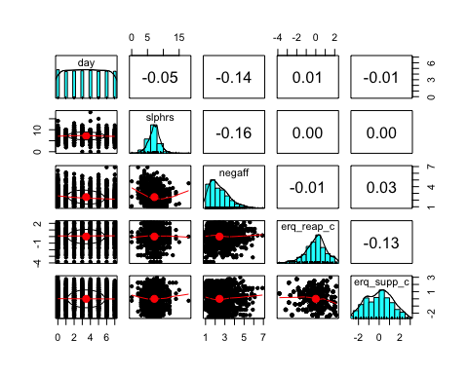

We see relatively weak correlations overall, but note a small negative correlation between **hours of sleep** and **negative affect** (-0.16), as well as a small negative correlation between **cognitive reappraisal** and **expressive suppression** (-0.13). We also observe a small negative correlation between **day** in study and **negative affect** (-0.14).

The distributions of the variables can be seen on the diagonal. Of particular interest, we note that the distribution of **cognitive reappraisal** scores has a negative skew, while the distribution of **expressive suppression** scores is relatively symmetrical.

## Linear regression: Negative affect vs. hours of sleep

We will now plot a simple, non-Bayesian linear regression of **negative affect** vs. **hours of sleep** to get a better sense of the association between our outcome variable and our main predictor variable.

ggplot(data=bpe_data, aes(x=slphrs, y=negaff)) +  
 geom_jitter(width = 0.35) +  
 geom_smooth(method=lm, lty=1, size=2) +  
 xlab("Hours of Sleep") + ylab("Negative Affect Level") +  
 theme_classic() +  
 theme(axis.title=element_text(size=12),  
 axis.text=element_text(size=12),  
 plot.title=element_text(size=14, hjust=.5)) +  
 theme(text = element_text(family = "Times New Roman")) +  
 ggtitle("Negative Affect vs. Sleep")

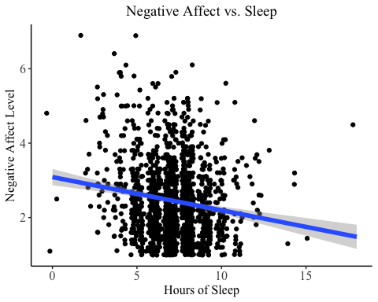

In general, more **hours of sleep** is associated with lower **negative affect**. However, many of the sleep durations correspond to a wide range of **negative affect** values, suggesting differences in **negative affect** across individuals.

# The Bayesian approach

## Bayes’ theorem

Before running our Bayesian models, we will briefly recap Bayes’ theorem. Bayes’ theorem gives us a mathematical expression for the probability of a hypothesis, H, conditional on (that is, given existing knowledge of) a body of evidence, E (Joyce, 2003/2021). The expression for Bayes’ theorem is

$$P\left(H|E\right)=\frac{P\left(E|H\right)P\left(H\right)}{P\left(E\right)}.$$

The posterior, $P\left(H|E\right)$, refers to the probability of the hypothesis being true after having observed the evidence. The likelihood, $P\left(E|H\right)$, refers to the probability of observing the evidence in the case where the hypothesis is already true. The prior, $P\left(H\right)$, refers to the probability of the hypothesis being true without having observed any evidence. Finally, the normalizing constant, $P\left(E\right)$, refers to the probability of the evidence occurring independent of any hypothesis.

## Bayesian interpretation

In general, Bayes’ theorem operates under the assumption that our refined degree of belief in H can be expressed in terms of (i) our prior, or existing, degree of belief in H and (ii) the contribution of newly observed evidence.

Of interest to parameter estimation, Bayes’ theorem allows us to calculate the probability distribution of a particular variable. In Bayesian parameter estimation, we use Bayes’ theorem to estimate the posterior distribution of a parameter value conditioned on our data, that is, $P\left(θ|D\right)$. Compared to frequentist parameter estimation, which calculates point estimates for parameter values, **Bayesian parameter estimation gives us a new way to quantify how uncertain we are about our parameter estimates through the use of probability distributions.**

# Cognitive reappraisal model

We will first estimate a model using the **cognitive reappraisal** score as a potential moderator for the relationship between the **hours of sleep** one reports on a particular night and their reported **negative affect** level the following day.

Note that we are using the *Bayesian regression models using ‘Stan’* package, or **brms**, (Bürkner, 2017) to fit our Bayesian models. This package allows the user to specify prior distributions for parameters. However, with a relatively simple linear model such as this one, we can instead allow brms to automatically select uninformative priors for the model’s parameters.

## Model equation

$$negaff_{it}=β_{0}+β_{1}day_{t}+β_{2}sleephours_{it}+β_{3}reappraisal_{i}+β_{4}sleephours_{it}×reappraisal_{i}+u_{it}$$

## Run model

bpe.reap <- brm(negaff ~ 1 + day + slphrs + erq_reap_c + slphrs:erq_reap_c  
 + (1 + slphrs + erq_reap_c|id),  
 data = bpe_data, family = gaussian(),  
 iter = 2000, chains = 4, cores = 4)

summary(bpe.reap)

## Family: gaussian   
## Links: mu = identity; sigma = identity   
## Formula: negaff ~ 1 + day + slphrs + erq_reap_c + slphrs:erq_reap_c + (1 + slphrs + erq_reap_c | id)   
## Data: bpe_data (Number of observations: 1421)   
## Draws: 4 chains, each with iter = 2000; warmup = 1000; thin = 1;  
## total post-warmup draws = 4000  
##   
## Group-Level Effects:   
## ~id (Number of levels: 190)   
## Estimate Est.Error l-95% CI u-95% CI Rhat Bulk_ESS  
## sd(Intercept) 0.97 0.13 0.73 1.23 1.00 1496  
## sd(slphrs) 0.09 0.02 0.05 0.13 1.00 500  
## sd(erq_reap_c) 0.09 0.07 0.00 0.25 1.00 783  
## cor(Intercept,slphrs) -0.75 0.09 -0.87 -0.52 1.00 1868  
## cor(Intercept,erq_reap_c) 0.03 0.47 -0.84 0.84 1.00 2270  
## cor(slphrs,erq_reap_c) -0.14 0.51 -0.94 0.83 1.00 1803  
## Tail_ESS  
## sd(Intercept) 2512  
## sd(slphrs) 875  
## sd(erq_reap_c) 1261  
## cor(Intercept,slphrs) 2162  
## cor(Intercept,erq_reap_c) 2633  
## cor(slphrs,erq_reap_c) 2619  
##   
## Population-Level Effects:   
## Estimate Est.Error l-95% CI u-95% CI Rhat Bulk_ESS Tail_ESS  
## Intercept 3.25 0.13 2.98 3.51 1.00 4293 3553  
## day -0.07 0.01 -0.09 -0.05 1.00 9786 2888  
## slphrs -0.08 0.02 -0.11 -0.05 1.00 4587 3403  
## erq_reap_c -0.01 0.12 -0.25 0.22 1.00 3689 2957  
## slphrs:erq_reap_c 0.00 0.02 -0.03 0.03 1.00 3457 2898  
##   
## Family Specific Parameters:   
## Estimate Est.Error l-95% CI u-95% CI Rhat Bulk_ESS Tail_ESS  
## sigma 0.78 0.02 0.75 0.81 1.00 2750 2918  
##   
## Draws were sampled using sampling(NUTS). For each parameter, Bulk_ESS  
## and Tail_ESS are effective sample size measures, and Rhat is the potential  
## scale reduction factor on split chains (at convergence, Rhat = 1).

bayes_R2(bpe.reap)

## Estimate Est.Error Q2.5 Q97.5  
## R2 0.4444879 0.0181962 0.4081642 0.4794015

## Interpret results

### Check model convergence

We see that all R-hat values are $≤$ 1.01, which indicates good convergence.

### Assess 95% credible intervals

Since a Bayesian model does not give us *p*-values like a traditional frequentist model would, we can instead use something called a **95% credible interval** to examine statistical significance. We receive two values for each estimated parameter: the interval’s lower bound (l-95% CI) and the interval’s upper bound (u-95% CI). Given the data, the probability that the true parameter lies between these values is 0.95.

One way to evaluate a 95% credible interval is to see whether the interval contains 0. If 0 falls within the 95% credible interval, this suggests that the parameter may not be significant. If 0 does not fall within the 95% credible interval, we can be reasonably sure that the parameter is significant.

For this model, the credible intervals of **day** and **hours of sleep** do not contain 0, suggesting significant associations between these variables and **negative affect**. However, the credible intervals of **cognitive reappraisal** and the interaction between **hours of sleep** and **cognitive reappraisal**, the predictors we are most interested in, do contain 0. Thus, we might doubt the significance of these parameters.

### View posterior distributions of parameters

plot(bpe.reap)

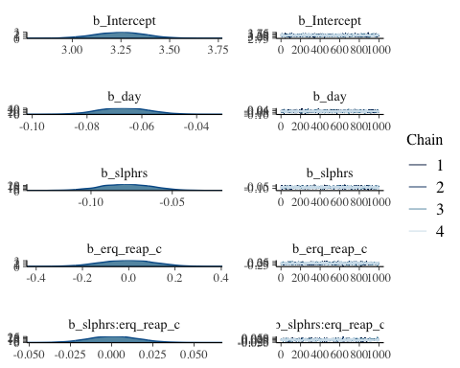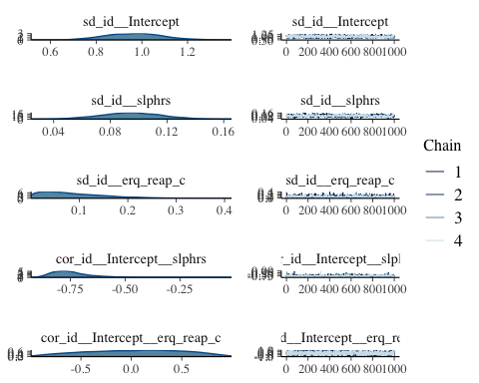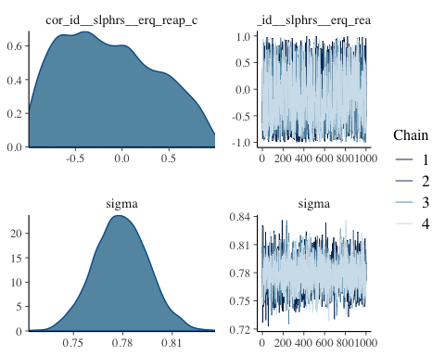

We can generate plots to visualize the posterior distributions for our estimated parameters. Most parameters appear relatively normally distributed, with a few positively- and negatively-skewed exceptions.

## Visualize model

We plot the model’s predictions for **negative affect** vs. **hours of sleep** for “high” ( $≥$ 0) and “low” ( $<$ 0) centered **cognitive reappraisal** scores.

# save model predictions to dataset  
bpe_data$pred_reap <- predict(bpe.reap, newdata=bpe_data, allow_new_levels=TRUE)  
# discretize reappraisal variable for plotting purposes  
bpe_data$erq_reap_hl <- ifelse(bpe_data$erq_reap_c >= 0, "High", "Low")  
  
ggplot(data = bpe_data, aes(x = slphrs, y = pred_reap[,"Estimate"],  
 color = erq_reap_hl)) +  
 geom_jitter(size = .75, width = 0.35) +  
 geom_smooth(method = lm) +  
 xlab("Hours of Sleep") +  
 ylab("Negative Affect") +  
 theme_classic() +  
 theme(axis.title=element_text(size=12),  
 axis.text=element_text(size=12),  
 plot.title=element_text(size=14, hjust=.5)) +  
 theme(text = element_text(family = "Times New Roman")) +  
 ggtitle("Negative Affect vs. Sleep\nfor High and Low Reappraisal Individuals") +  
 labs(colour = "Cognitive Reappraisal Score")

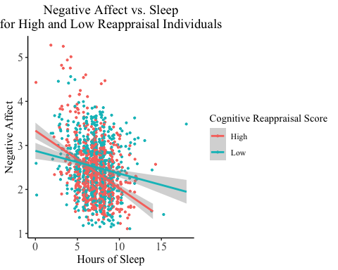

### Read plot

In this visualization, each point plots an individual’s reported **negative affect** on a particular day against the number of **hours of sleep** they report from the prior night. Points are color coded to indicate whether the individual has a high (coral) or low (turquoise) **cognitive reappraisal** score.

The coral regression line represents the aggregate of individuals with high **cognitive reappraisal** scores, while the turquoise regression line represents the aggregate of individuals with low **cognitive reappraisal** scores. The slope of each line indicates the strength of the association between **hours of sleep** at night and **negative affect** the following day for that group. We note that the coral line has a more negative slope than the turquoise line, indicating a stronger association between **hours of sleep** and **negative affect** for the high **cognitive reappraisal** group.

### Interpret plot

We observe that having a higher **cognitive reappraisal** score may predict a larger difference in **negative affect** for a fixed difference in **hours of sleep**. In other words, it appears that those with higher **cognitive reappraisal** scores report **negative affect** that is more closely related to how many **hours of sleep** they got the previous night. This may suggest that **cognitive reappraisal** is most effective in decreasing **negative affect** when an individual has gotten sufficient **hours of sleep**.

# Expressive suppression model

Next, we will estimate a very similar model to examine the **expressive suppression** score as a potential moderator, in place of the **cognitive reappraisal** score.

## Model equation

$$negaff_{it}=β_{0}+β_{1}day_{t}+β_{2}sleephours_{it}+β_{3}suppression_{i}+β_{4}sleephours_{it}×suppression_{i}+u_{it}$$

## Run model

bpe.supp <- brm(negaff ~ 1 + day + slphrs + erq_supp_c + slphrs:erq_supp_c  
 + (1 + slphrs + erq_supp_c|id),  
 data = bpe_data, family = gaussian(),  
 iter = 2000, chains = 4, cores = 4)

summary(bpe.supp)

## Family: gaussian   
## Links: mu = identity; sigma = identity   
## Formula: negaff ~ 1 + day + slphrs + erq_supp_c + slphrs:erq_supp_c + (1 + slphrs + erq_supp_c | id)   
## Data: bpe_data (Number of observations: 1421)   
## Draws: 4 chains, each with iter = 2000; warmup = 1000; thin = 1;  
## total post-warmup draws = 4000  
##   
## Group-Level Effects:   
## ~id (Number of levels: 190)   
## Estimate Est.Error l-95% CI u-95% CI Rhat Bulk_ESS  
## sd(Intercept) 0.94 0.13 0.71 1.20 1.00 1670  
## sd(slphrs) 0.09 0.02 0.05 0.13 1.01 472  
## sd(erq_supp_c) 0.10 0.07 0.00 0.26 1.01 479  
## cor(Intercept,slphrs) -0.74 0.10 -0.87 -0.49 1.00 1907  
## cor(Intercept,erq_supp_c) 0.34 0.41 -0.63 0.93 1.00 1916  
## cor(slphrs,erq_supp_c) -0.16 0.46 -0.90 0.80 1.00 1615  
## Tail_ESS  
## sd(Intercept) 1855  
## sd(slphrs) 889  
## sd(erq_supp_c) 865  
## cor(Intercept,slphrs) 2034  
## cor(Intercept,erq_supp_c) 2716  
## cor(slphrs,erq_supp_c) 2226  
##   
## Population-Level Effects:   
## Estimate Est.Error l-95% CI u-95% CI Rhat Bulk_ESS Tail_ESS  
## Intercept 3.23 0.13 2.97 3.48 1.00 4327 3509  
## day -0.07 0.01 -0.08 -0.05 1.01 9545 2747  
## slphrs -0.08 0.02 -0.11 -0.05 1.00 4640 3325  
## erq_supp_c 0.09 0.10 -0.10 0.29 1.00 2932 3150  
## slphrs:erq_supp_c -0.01 0.01 -0.03 0.01 1.00 3454 3304  
##   
## Family Specific Parameters:   
## Estimate Est.Error l-95% CI u-95% CI Rhat Bulk_ESS Tail_ESS  
## sigma 0.78 0.02 0.75 0.81 1.00 3633 2975  
##   
## Draws were sampled using sampling(NUTS). For each parameter, Bulk_ESS  
## and Tail_ESS are effective sample size measures, and Rhat is the potential  
## scale reduction factor on split chains (at convergence, Rhat = 1).

bayes_R2(bpe.supp)

## Estimate Est.Error Q2.5 Q97.5  
## R2 0.4445531 0.01780555 0.4078836 0.478251

## Interpret results

### Check model convergence

We see that all R-hat values are $≤$ 1.01, which indicates good convergence.

### Assess 95% credible intervals

We again will use each parameter’s **95% credible interval** to assess its significance. As a reminder, the probability, given the data, that the true parameter falls within the credible interval is 0.95. We can evaluate a 95% credible interval by seeing whether the interval contains 0.

For this model, the credible intervals of **day** and **hours of sleep** do not contain 0, suggesting significant associations between these variables and **negative affect**. However, the credible intervals of **expressive suppression** and the interaction between **hours of sleep** and **expressive suppression**, the predictors we are most interested in, do contain 0. Thus, we might doubt the significance of these parameters.

### View posterior distributions of parameters

plot(bpe.supp)

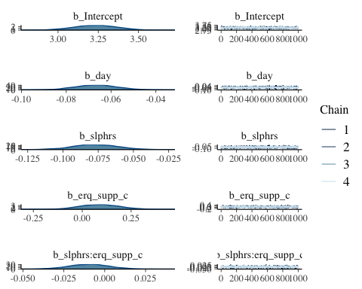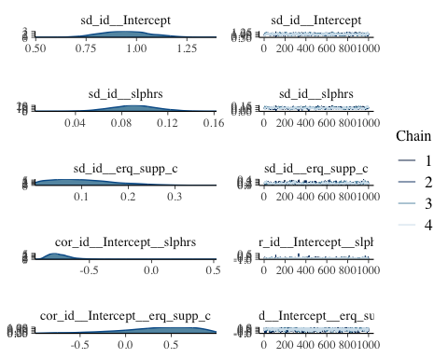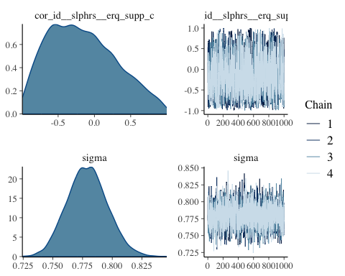

We can generate plots to visualize the posterior distributions for our estimated parameters. Most parameters appear relatively normally distributed, with a few positively- and negatively-skewed exceptions.

## Visualize model

We plot the model’s predictions for **negative affect** vs. **hours of sleep** for “high” ( $≥$ 0) and “low” ( $<$ 0) centered **expressive suppression** scores.

# save model predictions to dataset  
bpe_data$pred_supp <- predict(bpe.supp, newdata=bpe_data, allow_new_levels=TRUE)  
# discretize suppression variable for plotting purposes  
bpe_data$erq_supp_hl <- ifelse(bpe_data$erq_supp_c >= 0, "High", "Low")  
  
ggplot(data = bpe_data, aes(x = slphrs, y = pred_supp[,"Estimate"],  
 color = erq_supp_hl)) +  
 geom_jitter(size = .75, width = 0.35) +  
 geom_smooth(method = lm) +  
 xlab("Hours of Sleep") +  
 ylab("Negative Affect") +  
 theme_classic() +  
 theme(axis.title=element_text(size=12),  
 axis.text=element_text(size=12),  
 plot.title=element_text(size=14, hjust=.5)) +  
 theme(text = element_text(family = "Times New Roman")) +  
 ggtitle("Negative Affect vs. Sleep\nfor High and Low Suppression Individuals") +  
 labs(colour = "Expressive Suppression Score")

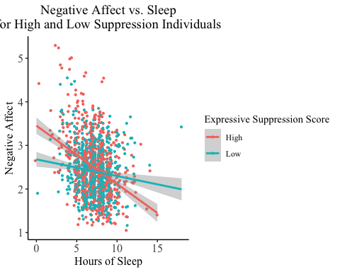

### Read plot

In this visualization, each point plots an individual’s reported **negative affect** on a particular day against the number of **hours of sleep** they report from the prior night. Points are color coded to indicate whether the individual has a high (coral) or low (turquoise) **expressive suppression** score.

The coral regression line represents the aggregate of individuals with high **expressive suppression** scores, while the turquoise regression line represents the aggregate of individuals with low **expressive suppression** scores. The slope of each line indicates the strength of the association between **hours of sleep** at night and **negative affect** the following day for that group. We note that the coral line has a more negative slope than the turquoise line, indicating a stronger association between **sleep** and **negative affect** for the high **expressive suppression** group.

### Interpret plot

We observe that having a higher **expressive suppression** score may predict a larger difference in **negative affect** for a fixed difference in **hours of sleep**. In other words, it appears that those with higher **expressive suppression** scores report **negative affect** that is more closely related to how many **hours of sleep** they got the previous night. This may suggest that **expressive suppression** is most effective in decreasing **negative affect** when an individual has gotten sufficient **hours of sleep**.

We observe that the moderating effects of **cognitive reappraisal** and **expressive suppression** appear similar, suggesting that a more general factor is moderating the relationship between **hours of sleep** and **negative affect**. We may want to investigate this further in future work.

# Model comparison

We will now use leave-one-out cross-validation (LOOCV) to compare the relative fits of the **cognitive reappraisal** model and the **expressive suppression** model. This type of model comparison is typically done between two different kinds of models using the same data. Our models have the same form but use slightly different data (reappraisal predictor vs. suppression predictor). However, for demonstrative purposes, we will stil compare them using LOOCV.

bpe.reap <- add_criterion(bpe.reap, c("loo"))  
bpe.supp <- add_criterion(bpe.supp, c("loo"))  
loo_compare(bpe.reap, bpe.supp)

## elpd_diff se_diff  
## bpe.supp 0.0 0.0   
## bpe.reap -0.6 1.5

We observe that the **cognitive reappraisal** model appears to have a better fit than the **expressive suppression** model. This indicates that the relationships among variables in the **cognitive reappraisal** model are better suited to a linear model than those in the **expressive suppression** model. A LOOCV comparison would likely give us more helpful information if we were comparing, for example, a linear version of the **cognitive reappraisal** model and a nonlinear version of the **cognitive reappraisal** model.

Beyond using formal quantitative techniques like LOOCV for model comparison, it can be helpful to compare the plotted posterior distributions of parameters across the two models. This can help us understand the relative levels of uncertainty we have in those models.

# Conclusion

Shifting from a frequentist understanding of parameter estimation to a Bayesian understanding can be challenging, and it is important to consider the merits and drawbacks of both approaches. Bayesian parameter estimation can seem unintuitive at first, but it provides us with new tools to describe and analyze the uncertainty inherent in our data. **In social science research, being able to incorporate subjectivity into our models can give us a new outlook on phenomena that are often hard to pin down in a standard quantitative framework.**

## Additional resources

If you would like to learn more about the concepts mentioned in this tutorial, here are a few external resources:

* The mathematics behind Bayesian parameter estimation: <https://ccrma.stanford.edu/~jos/bayes/Bayesian_Parameter_Estimation.html>
* Advanced topics on Bayesian parameter estimation: <http://www.ece.virginia.edu/~ffh8x/docs/teaching/esl/2020-04/farnoud-slgm-chap03.pdf>
* The brms package: <https://paul-buerkner.github.io/brms/>
* Confidence and credible intervals: <https://www.ncbi.nlm.nih.gov/pmc/articles/PMC6630113/>

# References

Bürkner, P.-C. (2017). brms: An R package for Bayesian multilevel models using Stan. *Journal of Statistical Software*, *80*(1). <https://doi.org/10.18637/jss.v080.i01>

Gross, J. J., & John, O. P. (2003). Individual differences in two emotion regulation processes: Implications for affect, relationships, and well-being. *Journal of Personality and Social Psychology*, *85*(2), 348–362. <https://doi.org/10.1037/0022-3514.85.2.348>

Joyce, J. (2021). Bayes’ theorem (E. N. Zalta, Ed.). *The Stanford Encyclopedia of Philosophy* (Fall 2021 Edition). <https://plato.stanford.edu/archives/fall2021/entries/bayes-theorem/> (Original work published 2003)

Kahn, M., Sheppes, G., & Sadeh, A. (2013). Sleep and emotions: Bidirectional links and underlying mechanisms. *International Journal of Psychophysiology*, *89*(2), 218–228. <https://doi.org/10.1016/j.ijpsycho.2013.05.010>

Ram, N., Conroy, D. E., Pincus, A. L., Hyde, A. L., & Molloy, L. E. (2012). Tethering theory to method: Using measures of intraindividual variability to operationalize individuals’ dynamic characteristics. In G. Hancock & J. Harring (Eds.), *Advances in longitudinal methods in the social and behavioral sciences* (pp. 81-110). New York: Information Age.